

DIGITAL MARKETING INTERN AT GHS EDUCATIONAL ASSISTANCE

**Internship Report**

SUBMITTED BY, ABU MOHAMMAD FAHIM ID: 1621621 SECTION 08

SUBMITTED TO, SANZAR ADNAN ALAM

Date 30.05.2021

# LETTER OF SUBMITTAL

I take the pleasure to submit my report titled *“Digital Marketing (Intern) at GHS Educational Assistance”*. The report provided me ample opportunity to experience the real-life marketing environment, modern technology and techniques. I hope that will ensure positive role in the development of my future career. In this report, I tried to summarize what I have done and experienced during my internship period in GHS Educational Assistance.

My internship experience will remain as a great achievement in building my career. I have gained practical experience with industrial marketing of software and business policy. I have also acquired opportunity on professional interaction at different levels including helping, advising, and providing feedback. My supervisor was very cooperative, generous, and open minded so that I was able to interact freely and friendly. The report explores the different aspects of the digital marketing profession.

I am really lucky to have the chance to take part in this internship program. I express my sincere gratitude and thankfulness to my supervisor, for guiding me continuously for successful completion of the internship report.

Yours sincerely,

__________________

**Abu Mohammad Fahim**

ID: 1621621

Date: 30.05.2021

**ACKNOWLEDGEMENT**

It gives me immense pleasure to express my deepest sense of gratitude and sincere thanks to our highly respected and esteemed guides First and foremost I want to thank Almighty Allah for giving me an opportunity to complete the internship project.

Next I would like to take the opportunity to thank my supervisor for his valuable guidance, encouragement and help for completing this work. His precious suggestions and support helped me to complete this project

I owe my deep sense of gratitude to Mr. Shahan Hossain Prodhan Chief Marketing Officer at GHS Educational Assistance for choosing me as an intern in the organization and helping me throughout my internship journey.

Lastly, I would like to express my heartfelt gratitude to my family and friends for the immense support throughout the time.

**Table of Contents**

1. **INTRODUCTION…………………………………………… 05-06**
2. Background………………………………………………………………………05
3. Objectives………………………………………………………………………...06
4. Scope…………………………………………………………………………….06
5. **LITERATURE REVIEW…………………………………….07-09**
6. How the work is related to undergraduate courses……………………………….07
7. Related Works…………………………………………………………………….08
8. **METHODOLOGY……………………………………………09-12**
9. **PROJECT MANAGEMENT AND FINANCING………….12-14**
10. Work Breakdown Structure (WBS)……………………………………………….12
11. Activity Wise Time Distribution………………………………………………….13
12. Activity Wise Resource Allocation……………………………………………….14
13. Estimated Costing…………………………………………………………………14
14. **BODY OF THE PROJECT………………………………….14-20**
15. Description of the Work…………………………………………………………….14
16. System Analysis………………………………………………………………….…18
17. System Design………………………………………………………………………19
18. Functional and Non-Functional Requirements……………………………………...20
19. **RESULT AND ANALYSIS…………………………………….20**
20. **WORK AS ENGINEERING PROBLEM ANALYSIS……….21**
21. Sustainability of the Work…………………………………………………………....21
22. Social and Environmental Effect and Analysis……………………………………….21
23. Addressing Ethics and Ethical Issue………………………………………………….21
24. **FUTURE WORK AND CONCLUSION……………………….22**
25. **REFERENCES………………………………………………….23**
26. **Introduction**
27. **Background**

**GHS Educational Assistance:**

GHS is an educational assistance agency. Here we are working with students helping them study abroad. Therefore, as everything is technology based in the present world digital marketing and use of technology plays a vital role in the company’s day to day work. Starting from posting the daily updates of the company to keeping the everyday records everything is done through advanced software and technology. The services include the following:

* Student Counselling
* Canada Immigration
* Ielts guidance
* Ticketing

Marketing is an essentially important element in every organization. Therefore, GHS has a strong marketing team expertise in Digital Marketing. Nowadayscompanies prefer to advertise themselves through digital marketing as this is the most convenient way to reach viable customers. Therefore, we deploy various digital marketing skills and strategies in GHS to grab viable customers. The digital marketing used in GHS include:

* Facebook Marketing
* Email Marketing
* Commenting
* Instagram Marketing

Our marketing team is highly experienced and knowledgeable in all the fields of marketing be that, traditional or digital. It mainly focuses on all the aspects of digital marketing to reach its clients. We ensure that it helps larger number of people to know about our services and help them acquire our service. We also make ourselves available to the clients and make the services easy to access in order to enhance customer satisfaction.

**b. Objectives**

This internship report is prepared primarily to fulfill the Bachelor of Science (B. Sc.) in Computer Science Engineering (CSE) degree requirement under the Faculty of Computer Science Engineering. GHS Educational Assistance is a consultancy agency that helps students to study abroad and provide immigration assistance in Canada. Digital marketing is a vital element in advertising the agency and helps in reaching more customers for enhancing the customer network.

1. **Scope:**

Digital Marketing is the demand of the present time. It has huge demand in the market. Nowadays all the organizationsrequire digital marketing for their advertising therefore, Digital Marketing has a great scope in recent times. People nowadays spend more time in social media thus digital marketing is the ladder that helps reach a wide network of people(Dholakiya. 2015). Thus companies are more inclined towards digital marketing rather than traditional marketing. Therefore, the scope of digital marketing is growing with the rising need of the companies.

1. **Literature review:**
2. **How the work is related to undergraduate courses:**

**English:**

Throughout my undergraduate life I had two English courses. There we were taught about sentence structures, sentence making and various grammatical rules of English Language. We were also taught to write reports, letters, emails and assignments.

This courses helped me a lot throughout my internship. Firstly, when I joined GHS as a marketing intern, I was assigned to all carry out all the digital marketing works. For this, my writings came in handy. For email marketing, I needed to have knowledge about attractive writing skills so that my it could grab more customers. The things I learned in my English course helped me a lot to write the emails in an interesting yet very informative manner. I was highly praised for my writing ability throughout my internship period.

Next, the Facebook and Instagram marketing also requiredwriting skills. Such marketing requires tricky use of words in order to grab customers. The lessons taught in my class helped me to a large extent about how words can be arranged in such a way that would be short and also interesting to read. I successfully managed to grab a large number of customers due to the lessons learnt from these courses.

**Marketing:**

The marketing course I took gave me a great knowledge of marketing. Along with my engineering skills the marketing lessons learnt from the class helped me a lot in completing my internship successfully. There I was taught about branding, advertising, and different marketing tools. This course helped me to get new marketing ideas, and indeed helped me to acquire a special place in the company. By deploying the different marketing plans I could grab a large audience through Facebook and Instagram marketing.

Moreover, this course made be an eligible marketer who could take decisions on demand. GHS being a consultancy agent requires to grab potential clients and for this a smart marketing mind is a must. And it is because of this course that I could use the different knowledge at different times and proof myself as a successful digital marketer.

Lastly, I would also I like to talk about my major courses that gave me a broad idea about the competitive IT market environment. It made me a strong IT person with great knowledge of coding and software designing. It is because of these courses that I could recognize myself as a digital marketer and felt confident while working in the real world as a digital marketing intern. I now look forward to facing the new challenges and work in an IT firm where I can utilize the knowledge I gathered from my courses and this internship. It made me an strong individual as well as a confident professional who is ready to grab every new opportunities.

1. **Related Works:**

I also did related works of digital marketing for other online pages such as Stylemeology. Stylemeology is an online dress shop.Stylemeology was the first shop I worked with. It gave a great experience and field to develop my skills which later helped me a lot during my internship in GHS. Here I made various posts, and worked to boost those posts. I also had to write attractive captions that would flourish the products and help to grab more customers. I also had to share the pictures in various groups keeping it mind that it is relevant and people are finding it interesting. I also worked in commenting. I made automated messages for the page in order to give the customers an easy shopping experience. I also worked as a commenter of the online page and all these experiences were equally used when I worked as a digital marketer intern in GHS Educational Assistance. Some of the pictures of my work are shared below:

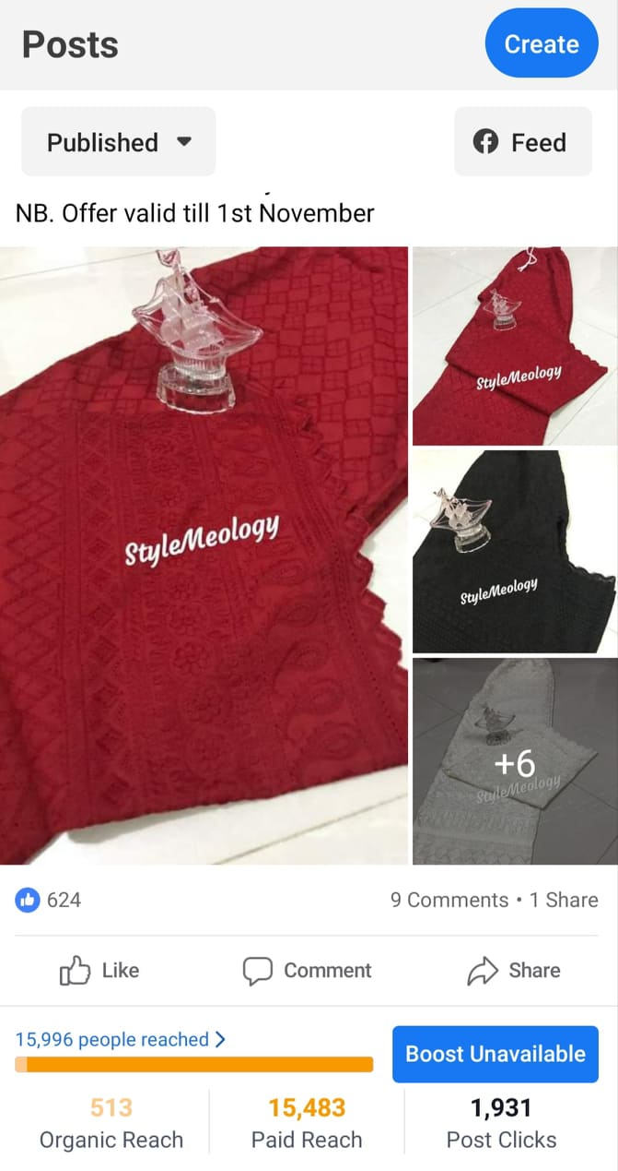

**3. Methodology:**

**Searching an organization:**

The first task for my internship course was to find an organization that is relevant to my field of study. It was a big challenge in the beginning as I was acquainted with hardly any IT company. I applied for internship in few organizations and most of them required in in place service for internship completion. As I took internship during the corona virus pandemic it was feasible for me to work from home and it was only offered in GHS. Therefore, I took the opportunity to work in GHS Educational Assistance as the digital marketing intern.

**Activities as Intern:**

I had to go to the Office of GHS Educational Assistance located in Mohakhali for my first day as an intern. I had to go there to collect my offer letter and get the briefing of the tasks that I would be assigned. On entering the office, it gave a vive of professionalism; a new chapter of my life. At first the receptionist guided me towards the room of the chief marketing executive of GHS Mr. Shahan Hossain Prodhan. He was a very friendly and professional person who taught me a lot throughout my internship period. He handed me a paper which was my offer letter. Then he began to give me a brief about the rules and regulations of the organization. As this is an educational assistance organization rules and regulations were strictly maintained throughout the organization. Time and deadline were among the strictest rules of the organizations. I was told to strictly follow deadline of the tasks and be cooperative in all the tasks assigned to me. He also told be the importance of proper maintenance of my tasks, as this is about assisting students, a simple mistake could cost huge trouble for the organization therefore, precision was a must while working in the organization. Furthermore, he also briefed about how the works need to be carried about and how to maintain the quality of the work. As I was an intern I was also given some flexibility of work and asked to choose my filed of expertise. He also assured me that he would guide me in all the tasks I will be assigned this gave a lot of confidence to start this new journey of my internship.

Next, step was assigning the tasks, the moment I was eagerly waiting for. Digital marketing is a huge area of work. So, He assigned me the task to look after their Facebook marketing, Instagram marketing, commenting in both Facebook and Instagram and email marketing. All of them were quite challenging for me, as this was my first time of working in a real world organization.

For Facebook marketing I had to create new contents and post them. This was very challenging as finding the potential clients and targeting them is not an easy task. I had to do a lot of research on the target audience and the type of people who love would like to know about the services provided by the organization. Furthermore, selecting the zone of the people that would be the potential client of the organization was also a challenge. As the office was located in Dhaka, and it is a huge area, understanding the nature of the people and their interest in studying abroad was quite a challenge which I think I accomplished quite successfully.

Not only this, Instagram marketing was also quite challenging. Iwas asked to enhance the followers of the Instagram page and engage as many real clients as possible. Therefore, I had to make strategy to enhance the Instagram follower. I did a brief research on the Instagram popular hashtagthat is followed by people having similar interests. I used those hastags and it helped me a lot to successfully increase the Instagram follower of the organization. Not only this, I managed to give a good number of clients through my marketing strategy.

The email marketing was most difficult for me. I had to do lead generation which is very time consuming. Therefore, I had to spend a lot of time to accomplish the lead generation of the viable clients of the organization. It was quite interesting to do. Additionally, I also had to design the email in a very professional way which would attract the clients and entice them to open and see my email. I also managed to grab some clients through this email marketing. Apart from designing writing the email in a precise and professional way is also important but as I learnt these things in my university previously this seemed quite easy to do.

As I was also assigned to do the commenting in both the pages I always had to remain active be that day or time. Therefore, even though the office time was 9-5 I had to stay active for 24hours. As everyday there were new contents there were queries of the clients which I had to answer and thus I had to spent a lot of time studying about their organization and the services they provide. Even though the tasks were quite lengthy but I enjoyed doing the work all through the time.

**Other Relevant Activities:**

As I worked there as a digital marketing intern, I needed to learn everything about their organization and about the type of services they provide. Therefore, I got a chance to attend few international seminars held online. This was a great learning experience for me as I got to attend seminar with a lot of corporate people who are highly experienced. I learnt a lot of new things which not only enhanced my knowledge but introduced me with abroader world. I learnt a lot about different universities, throughout the world which will surely help me in my life in future. This internship indeed helped in every aspect to be a better and more experienced individual. This made me more confident to meet new people, work under pressure and to be more punctual.

**4. Project Management & Financing**

**a. Work Breakdown Structure (WBS)**

Work Breakdown Structure is the breakdown of the tasks accomplished during the internship in GHS. It is the breakdown of the project into smaller components that makes the work easy to understand and manageable. The Work Breakdown Structure of my tasks in GHS is explained below:

Digital Marketer

**Fig. Work Breakdown Structure**

**b. Activity wise Time Distribution**

The time distribution of the tasks gives a detailed view of how I have spent my time in GHS as an intern. It shows the time for discussion of the project, research, the actual marketing and finally the documentation of the project.

|  |  |  |  |
| --- | --- | --- | --- |
| **Task Name** | **Start Date** | **Duration (hours)** | **End Date** |
| **Planning for the project** | **03.03.2021** | **10** | **05.05.2021** |
| **Discussion with the organization** | **07.03.2021** | **15** | **10.05.2021** |
| **Understanding the requirement** | **05.03.2021** | **6** | **06.05.2021** |
| **Project Research** | **06.03.2021** | **10** | **07.05.2021** |
| **Facebook Marketing** | **06.03.2021** | **10** | **09.05.2021** |
| **Instagram marketing** | **06.03.2021** | **7** | **09.05.2021** |
| **Email Marketing** | **06.03.2021** | **4** | **09.05.2021** |
| **Documentation** | **07.05.2021** | **6** | **09.05.2021** |

**c. Activity wise Resource Allocation:**

In order to complete the internship successfully some basic resources were required. The most important resource was the laptop which was a prerequisite to join GHS as an intern. Next was the Wi-Fi connection. Some other resources that helped me complete the internship was few software like canva, google adware, Microsoft word, and so on.

**d. Estimated costing**

An estimation of cost while planning a project helps to find out whether the project will be cost efficient or not and whether it can bring a considerable return compared to its cost or not. The estimated cost for each advertisement were around five thousand tk. There was other miscellaneous cost of the employees, software and hardware which was around one thousand takas.

**5. Body of the project**

**a. Description of the work:**

I was appointed as a digital marketing intern in GHS Educational Assistance. There I had to handle their social media marketing. It was a very interesting yet very challenging job. Marketing is crucial to every organization and digital marketing is the demand of the present time that helps the organization to be recognized among the clients(Kannan, Li, Hongshuang, 2017). Therefore, being a digital marketing intern I had a lot of responsibilities. Social media marketing is their major mean of marketing therefore, I got a lot to learn and use my knowledge of engineering during my work period in GHS. My responsibility was to perform the assigned tasks. During my work period I handles there Facebook page, Instagram and Email Marketing. The description of the tasks is given below:

**Facebook Page Marketing:**

The page was opened before I joined GHS. My first assignment was to post an advertisement about France. Therefore, I had to study a lot about the country to know about their universities, cost and other facilities. Then I designed the post and wrote the content. Since it was my first task choosing the audience was a big challenge but with the help of the marketing head of GHS I managed to do it. Them I had to choose a time frame of the advertisement and the cost. The outcomeof the advertisement came out to be pretty good and I was praised for the task I did. After this task I also made advertisements for other countries like France, Canada and so on. Some of the pictures of my work is shared below:

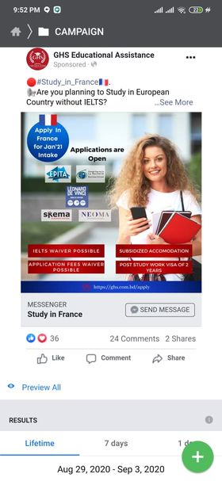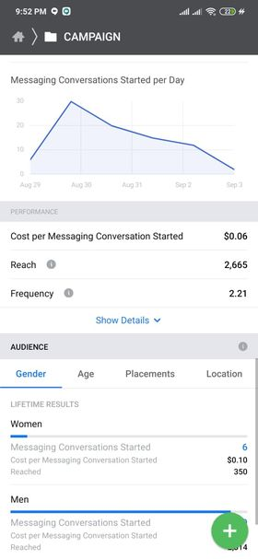

**Instagram Marketing:**

Instagram is another important part of social media marketing. The first assignment for Instagram marketing was to increase its followers. So in order to do that I had to post adds with popular hashtags. Therefore, I had to do hashtag research that would help to grab more clients that will be relevant to GHS. I finally managed to increase the number of follower and also managed to gain some relevant clients for GHS through the advertisements and strategy I followed. I had to do audience research for Instagram as well and it was quite challenging in the first task but with the help of my seniors and previous knowledge I managed to accomplish my job. Some of the pictures of my task is shared below:

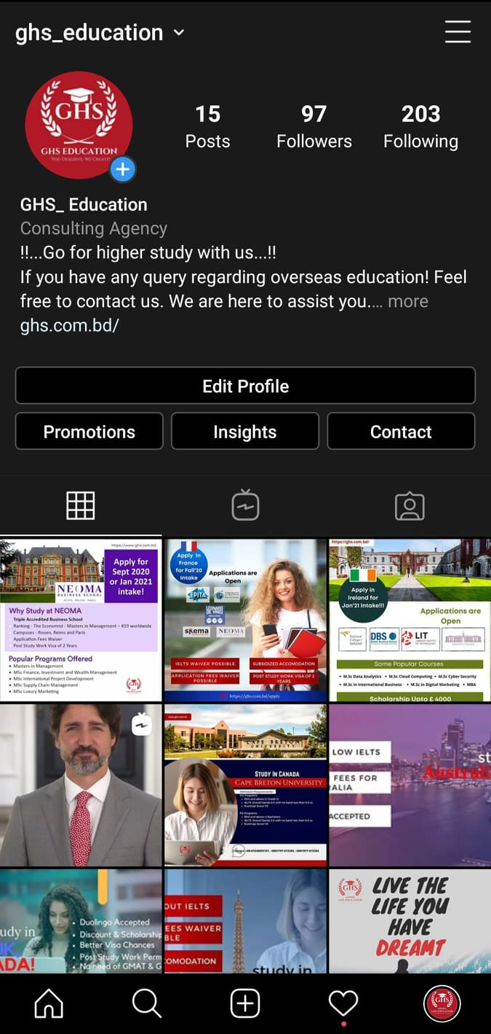

**Email Marketing:**

Email marketing is also a crucial part of social media marketing. Lead generation is a very important part of email marketing. Lead generation is about searching for viable emails of the clients that would find the advertisement useful and would like to know about the updates of GHS. This is very time management and requires a lot of research. I also did the designing of the email and write the email in the way that would be interactive and easily understood by the clients so that they would like to take services from GHS.

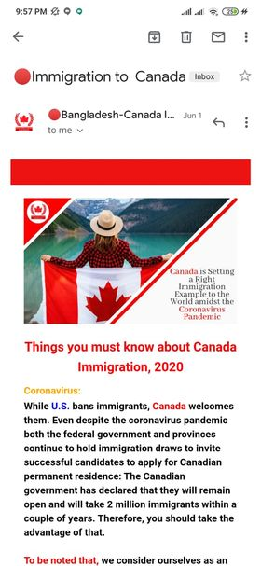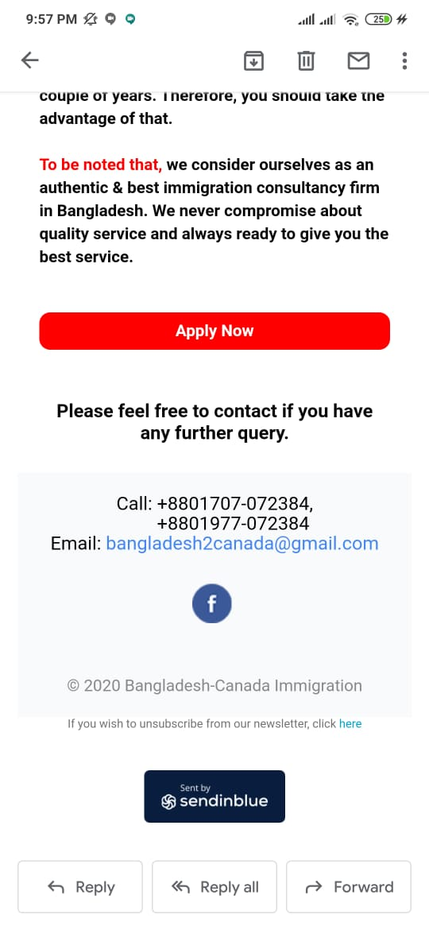

**b. System Analysis:**

System Analysis is the analysis of the feasibility of the resources required to accomplish the project. My Internship was on digital marketing, therefore, the users of my system was the clients of GHS. I had to recognize and find the relevant clients of GHS.I had to target these clients so that I could deliver the appropriate updates of the organizations only to people who would find it relevant. I used my laptop and Wi-Fi connection to reach the clients and accomplish the given tasks for my internship.

**Feasibility Analysis:**

It is the analysis of how swiftly the project can be done. It is study of the feasibility of the factors like economic, legal technical and scheduling of the tasks required for the completion of the project.

**Technical Feasibility:**

The technical feasibility is the analysis of the technical issues like availability of laptop Wi-Fi and the infrastructure required to complete the tasks assigned for the internship. It was quite feasible as I had all the elements required for completing my internship swiftly.

**Economic Feasibility:**

Economic feasibility is the analysis of the cost and its return, if the return is greater than the cost then it can be said to be economically feasible. The tasks I was assigned were economically feasible. They were inexpensive and brought more benefits compared to the cost required.

**Problem solution Analysis:**

It is the analysis of the barriers faced during the internship. One of the biggest barrier was the pandemic for which I had to work from home. There was communication gap due to this as all the communication and tasks were assigned through phone or emails at times there were some problems due to lack of communication. But nevertheless, as later we used zoom meeting for meetings it became easier and the communication gap did not affect the tasks anymore.

**Constrain Analysis:**

Constrain analysis is the analysis of any constrain faced during the internship. Being a digital marketing internship I did not face any constrains during my project I had the freedom to do my work on my own and as per my own choice as long as it met the requirements of the organization.

**c. System Design**

**Process Diagram:**

The figure below describes the process through which the work is assigned and accomplished in the organization.

Approve

Improvements

Broadcast

Social Media

Company

Task Design

Task Research

Job Assignment

Job Design

Deliver Task

Intern

Instruct

Supervisor

Instruct

Company

1. **Functional and Non-Functional Requirements:**

**Hardware Requirements:**

1. Laptop
2. Wi-Fi

**Software Requirements:**

1. Canva
2. Microsoft Word
3. Google Analytics
4. Google Ad wok
5. **Result and Analysis:**

Results are the outcome of the tasks that I did during my internship period.Theresult depends on the objective I had while joining the organization as an intern. The objectives were the basis of my achievement of the desired result. After my 3 months’ internship period I believe I achieved my objective successfully.

The organization where I worked as an intern was a consultancy agency. A strong marketing was a dire need of the organization. The major objective of the organization and its digital marketing team were as follows:

* Choose the target audience
* Make appropriate advertisements relevant to the organization
* Engage relevant customers through Facebook marketing audience selection.
* Make proper lead generation of the relevant clients.
* Design engaging Emails.
* Provide a target amount of clients after an advertisement

This marketing has been a success and the all the objectives of the organization were achieved as per the expectations of the management. Having done the social media marketing of the organization it enhanced my knowledge to a great extent and indeed the outcome of the tasks were great success as well. The internship period was the most tremendous period of my life as I had to face many challenges and this gave me a lot of new opportunities to explore new things to learn.

**7. Work as Engineering problem analysis**

**a. Sustainability of the work**

It refers to sustainability of my work during the internship period. Since digital marketing is the sole source of marketing in GHS it has high sustainability rate. Moreover, the task I did turned out to be quite successful therefore it was highly sustainable.

**b. Social and Environmental effects and analysis**

Every organization has their own social norms and culture. The social environment I found in GHS helped me grow my confidence level and also taught me the right way to convey my tasks. Moreover, I learnt how to maintain the social norms while doing my tasks and it made me more prepared to work as a software engineer after I complete my graduation.

While working in an organization environment is a very important factor. Though I worked mostly from home but their working environment was very friendly and helpful. Even though I was a tern there they treated me equally and assigned me with important projects. My supervisor was very helpful and assisted me in every task. Moreover, my seniors and fellow interns were a pleasure to work with.

**c. Addressing Ethics and ethical issue**

Ethics is a very important factor while working in an organization. There were mane ethical issues in GHS that were instructed to me on the very first day when I visited the office of GHS. Some of their most important ethics included maintaining discipline, time management and working as a team. This indeed made me very strong as a professional person because ethics is the basis of any performance in an organization.

1. **Future Work and Conclusion:**

The Internship program has been a great learning experience. It helped me to learn a lot of new things and gave me a real world experience. I got an opportunity to work with experienced people and learn to work from them. This also added value to my work experience which will help me in the future after my graduation.

The most important thing I learned from this internship is teamwork. I learnt how to work in team and follow the instructions while accomplishing the tasks. I learnt how teamwork helps one to grow as a person, as this improves the communication, understanding and most importantly time management. It also helped me to a large extent in improving my coding skills as GHS has a website. I could learn a lot from the seniors in GHS how to apply this coding skills in real life. These experiences and knowledge make me feel more prepared for my upcoming life.

As I worked in GHS as the digitalmarketing intern it helped me to get a proper knowledge of the real world.It boosted my confidence to talk to new people and mostly taught me professionalism. I learnt how to recognize the potential clients and target them through digital marketing. It also helped me improve my presentation skills and I learnt how to demonstrate the advertisements elaborately to the clients through email marketing. By attending various seminars which highly experienced people I learnt about discipline and time management. I learnt how important it is to make the best use of time and how important it is to be timely at everything. It gave a great boost to my discipline, knowledge and confidence.

Finally, it can be said that the internship has increased my skills and made me a stronger person professionally. It gave a strong knowledge of the real world working environment and made me accustomed to accomplishing the various tasks in a professional way. I am looking forward to working in this field in my future using my knowledge of internship.

1. **References:**

* [Digital Marketing Systems and Techniques"](https://warwick.ac.uk/fac/sci/wmg/education/wmgmasters/structure/modules/dmst/). Warwick.
* Pratik Dholakiya (14 April 2015). ["3 Digital Marketing Channels That Work for Every Advertiser"](http://www.entrepreneur.com/article/244802). Entrepreneur.
* [Digital Marketing Communication"](http://www.iccwbo.org/advocacy-codes-and-rules/areas-of-work/marketing-and-advertising/digital-marketing-communication/). iccwbo.org.
* Turner, Jamie; Shah, Reshma; Jain, Varsha (2018-03-01). ["How brands are using nonlinear marketing to address consumer resistance to traditional marketing strategies"](https://www.ingentaconnect.com/content/hsp/jbs/2018/00000006/00000004/art00008). www.ingentaconnect.com.
* PYMNTS (2018-01-09). ["Study Finds Consumers Research Before They Buy"](https://www.pymnts.com/news/retail/2018/omichannel-ecommerce-consumer-habits/). PYMNTS.com.
* ["10 Social Media Statistics You Need to Know in 2020 [Infographic]"](https://www.oberlo.com/blog/social-media-marketing-statistics). Oberlo.
* [Content Marketing Research: It Pays to Put Audience First"](https://contentmarketinginstitute.com/2018/10/research-b2b-audience/). Content Marketing Institute. 2018-10-10.
* [Why Brand Awareness Matters"](https://www.cmswire.com/digital-marketing/why-brand-awareness-matters/). CMSWire.com.
* ["Report Library"](https://datareportal.com/library). DataReportal – Global Digital Insights.
* ["How Social Media Can Help Businesses Win Loyal Customers | The Manifest"](https://themanifest.com/social-media/how-social-media-can-help-businesses-win-loyal-customers). themanifest.com.
* Booms, B.H. and Bitner, M.J., 2016. Marketing strategies and organization structures for service firms. Marketing of services, 25(3), pp.47-52
* Chaffey, D. and Ellis-Chadwick, F. (2012). Digital Marketing: Strategy, Implementation, and Practice. 1st ed. Harlow: Pearson Education.
* Ryan, D. (2014). Understanding Digital Marketing: Marketing Strategies for Engaging the Digital Generation Ed. 3. 1st ed. Kogan Page.
* Schiele, Kristen; Chen, Steven (2018-03-26). "Design Thinking and Digital Marketing Skills in Marketing Education: A Module on Building Mobile Applications". Marketing Education
* Kannan, P.K.; Li, Hongshuang “Alice” (2017). "Digital marketing: A framework, review and research agenda". International Journal of Research in Marketing. 34 (1): 22–45. [doi](https://en.wikipedia.org/wiki/Doi_(identifier)):[10.1016/j.ijresmar.2016.11.006](https://doi.org/10.1016%2Fj.ijresmar.2016.11.006).
* Doyle, Charles, 1959- (2016). A dictionary of marketing. Oxford University Press. (Fourth ed.). Oxford. [ISBN](https://en.wikipedia.org/wiki/ISBN_(identifier)) [978-0-19-180022-1](https://en.wikipedia.org/wiki/Special:BookSources/978-0-19-180022-1). [OCLC](https://en.wikipedia.org/wiki/OCLC_(identifier)) [957198795](https://www.worldcat.org/oclc/957198795).